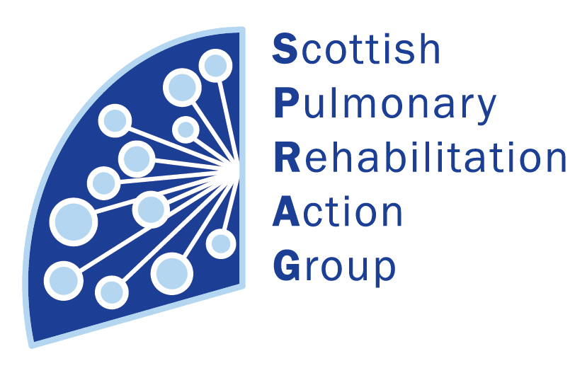**Scottish Pulmonary Rehabilitation Action Group (SPRAG) Conference 2017**

**Back to the Future**

Friday 16th June 2017 9.30am – 3.45pm

Lecture Theatre, Forth Valley Royal Hospital, Larbert

9.30am **Registration** **and Breakfast**

9.55am **Welcome** - Susan McNarry, Chair

10.00am **Anticipatory Care Planning in Respiratory Disease** – Karon Carson, Scottish Pulmonary Hypertension Team, Golden Jubilee Hospital

10.45am **Anticipatory Care Planning and Pulmonary Rehabilitation Workshops -**withKim Kirkwood, Karen Cason, Sue Begg & Linda Gray

11.45am **Patient Video**- Journey through a hospice

12 noon **Pulmonary Rehabilitation Report -** Jill Adams, CHSS

12.15 **Social Media –** Mhairi Stephen

12.30 – 1pm **Lunch**

1pm **Role of the committee plus** **AGM**

1.30pm **Back to Basics –** Dr Stuart Little, NHS Dumfries & Galloway

2.15pm **Workshops** –

* Chest clearance –Claire Hope
* Exercise, O2 and NIV – Jacquie Fabian
* Exercise in class – Elaine Mackay
* Assessment outcomes – Susan McNarry

3.45pm **Close -** Susan McNarry, Chair

**This event is kindly supported by Chest Heart & Stroke Scotland and GSK.** 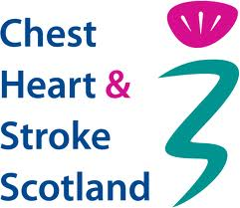 cid:image001.jpg@01D02E9E.8D8C3170