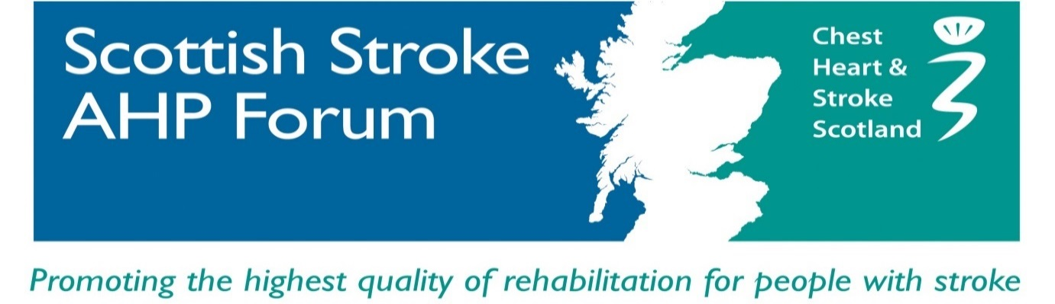
CONFERENCE REPORT – JUNE 2016
‘Living with Stroke’

The sun was shining on Scottish Stroke AHP Forum for our 4th annual conference which was held on June 9th at Dewar’s Centre, Perth. Once again, the conference was a sell out with over 100 delegates attending. The topic for the day was ‘Living with Stroke’.
The programme reflected the diverse nature of stroke symptoms and the speakers eloquently conveyed the impact that stroke has on the individual and their families. It also highlighted the wealth of treatment options available to therapists. The free paper presentations demonstrated a commitment to develop stroke research which will directly lead to improvements in clinical care. The positive energy throughout the day was inspiring and it was a great learning experience.
Feedback from those who attended was extremely encouraging:
It was an inspiring, motivating and informative day, I got so much from it. I have been raving about it ever since!
Very well organised professional course – will join SSAHP Forum as was not aware of it before

Very well run, informative day. Hearing the stories from the stroke survivors and carers was very powerful

Gill Alexander, Chair of Scottish Stroke AHP Forum, opened the conference with a warm welcome to all delegates. She gave a resume of SSAHPF activities this year which included research involvement and public engagement events. Membership of the Forum currently stands at 422 members.
Gill also launched the new updated SSAHPF website. The website is a really useful resource containing information on guidelines, stroke events, SSAHPF updates and much more. There is a section on the webpage devoted to the conference. Abstracts from each of the presentations can be accessed along with biographies from the speakers.
Our webpage is kindly hosted by CHSS. You can find us at:
www.SSAHPF.scot
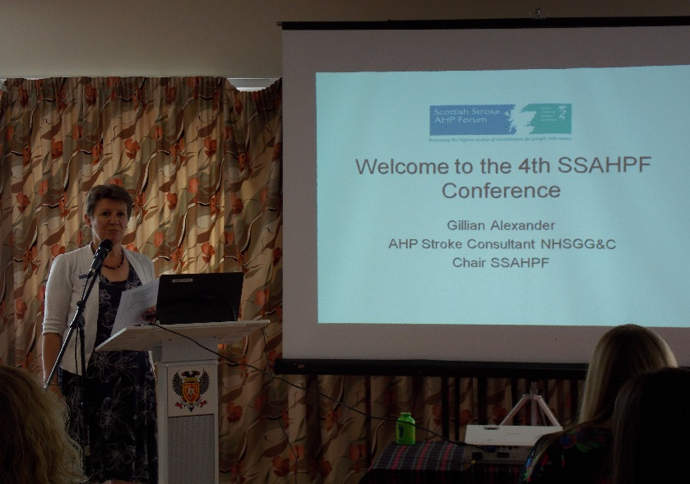

‘Living with Stroke’ was the theme off the day, so it was fitting that in the first symposium we heard from stroke survivors, Paul and Mark, and we listened to a carers perspective from Lynne. These speakers demonstrated positivity despite personal difficulties and their thought-provoking words where hugely motivating.
Paul’s presentation was titled ‘preaching the word - aphasia’. Paul described how having a stroke had turned his world upside down but his attitude to his life after stroke was inspiring. He talked about the work he does in promoting education about aphasia; he is involved in the education sessions to university students, health care professionals and the corporate sector.
Mark recounted his experience of suffering a stroke and his journey of recovery. He expressed his gratitude to the health professionals involved in his care and concluded that ’perseverance is key’. He discussed the importance of setting stretching but achievable goals and involving family members.
Lynne gave a personal reflection on the impact a stroke can have on family members, and how it can turn a daughter into a carer. She spoke about the practical and emotional challenges involved looking after someone who has had a stroke. Lynne’s presentation raised real questions about how we can improve communication between professionals and patients /carers.

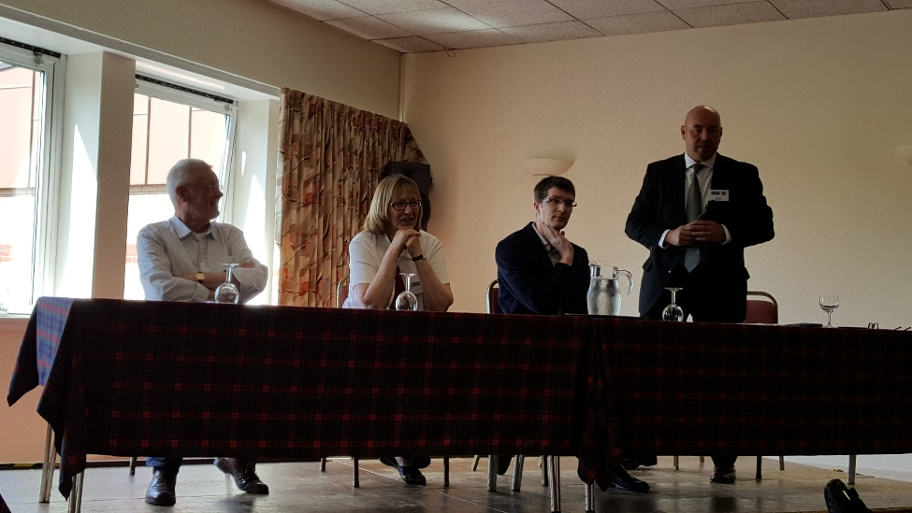

Free Paper Presentations:
The conference schedule continued with the presentation of free papers (abstracts are on our website). These sessions gave an overview of new developments in stroke care and gave an update on recent research projects. The quality of the work presented and the range of topics covered was interesting and informative. The papers promoted evidenced-based practice which had direct clinical relevance.

SESSION 1:
- Impact of incontinence after stroke, Prof Jo Booth
- What are the priorities for stroke rehabilitation technologies? Dr Andrew Kerr
- The use of commercial gaming devices in upper limb rehabilitation: the experience of stroke survivors, Ms Katie Thomson

SESSION 2:
- Physical activities for non-ambulatory stroke survivors (PHANSS-1) : exploring the thoughts and views of health and exercise professionals,
Ms Megan Lloyd
- The long term effect of wearing an ankle foot orthosis: the experience of stroke survivors, Dr Anne Taylor

Dr Jacqui Morris led an interactive workshop on the challenges of implementing evidence-based guidelines into practice. Participants discussed the barriers to implementation and the processes required to overcome these barriers.
Dr Morris identified the need to improve implementation science
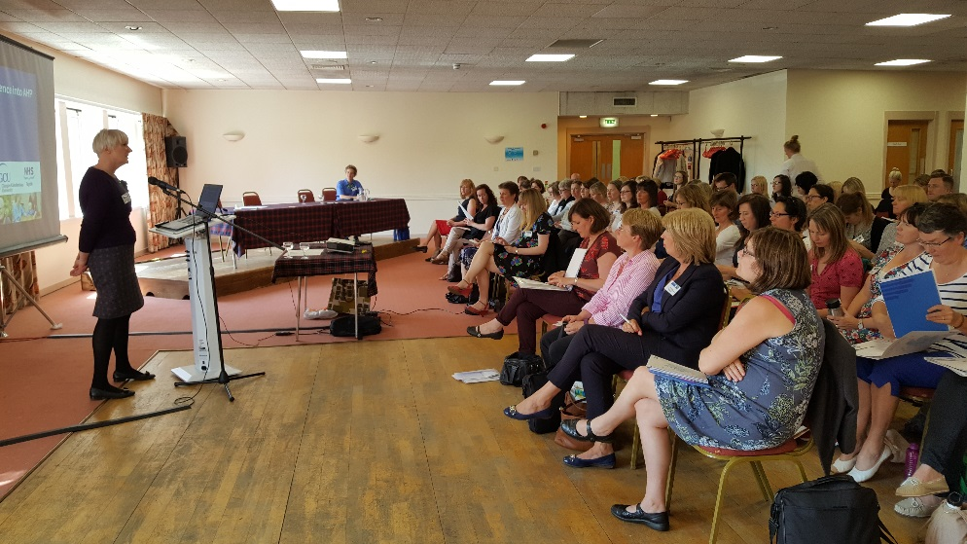

The final session of the day was dedicated to National Policy:
Mrs K Brennan, Scottish Government Improvement Lead, gave an update on the Scottish Stroke Improvement Plan, reviewing priorities and RAG status. She acknowledged that work needs to be done to identify what community rehabilitation should look like for stroke patients. A report from the Scottish Stroke Care Audit rehab sprint audit concluded her interesting presentation.
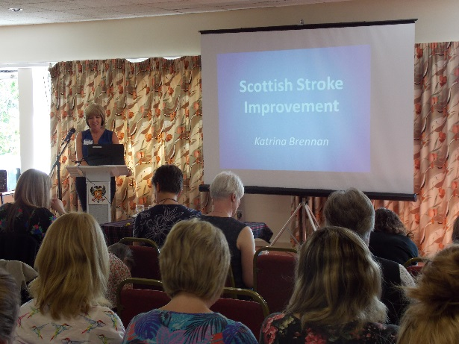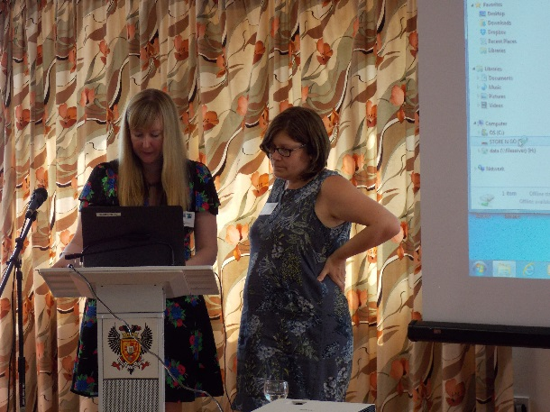

Ms H McFarlane, Scottish Government Associate Chief Health Professions Officer, gave an informative insight into future policy from the Scottish Government. She discussed the Active, Independent Living Improvement Programme and the implications it has for stroke services. Work is currently underway to develop a ‘workforce : workload’ measurement tool for AHPs. Further information is available on the following website:
www.knowledge.scot.nhs.uk/ahpcommunity.aspx

One of the aims of the Scottish Stroke AHP Forum is to facilitate networking. The conference was a great opportunity to meet old friends and get to know new colleagues. The trade stands provided a wealth of knowledge from a variety of different fields. The poster presentations were of a high standard and displayed exciting projects which are being carried out across the country.

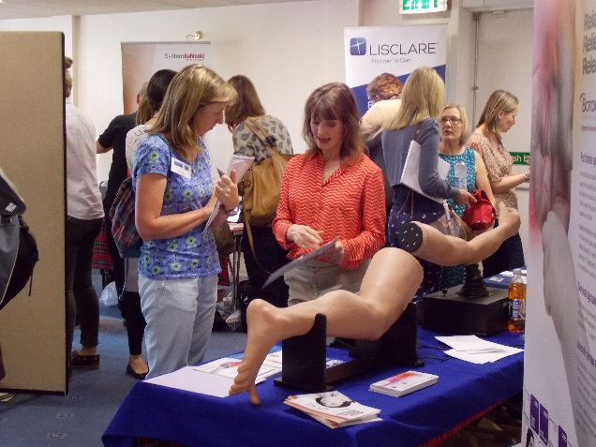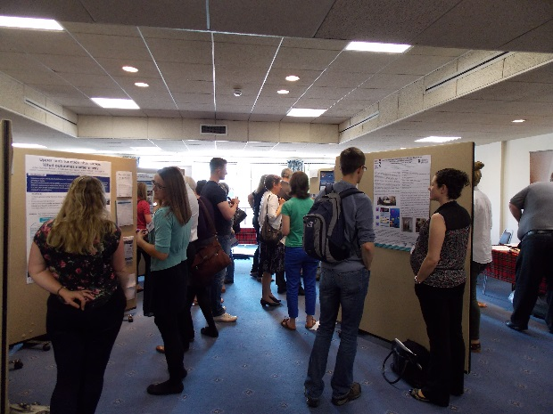

SSAHPF AGM:
The annual general meeting for the Forum was held at the conference. A report was given from the secretary and treasurer. The election of new committee members took place and thanks were offered to those committee members who stepped down from their roles.
The committee comprises of representatives from each Health Board in Scotland and from a variety of AHP professions. Please make sure you know who your local representative is as they will invite you to participate in SSAHPF activities.

In summary – a good day was had by all. The 2016 conference was a great success: it provided lots of examples of evidence-based practice, it provoked interesting discussions and offered guidance on how to live well after stroke.
Thank you to all delegates for your contributions on the day, thanks also to the SSAHPF conference committee and Chest, Heart and Stroke Scotland for their assistance in organising the event.
Look out for flyers about the 2017 conference- remember the last two years have sold out to don’t delay in applying for a place. Hope to see you next year!

