Title: Mr Mrs Miss Ms Dr Prof  First Name:  Surname:  Organisation/Address  Postcode:  E-mail: | 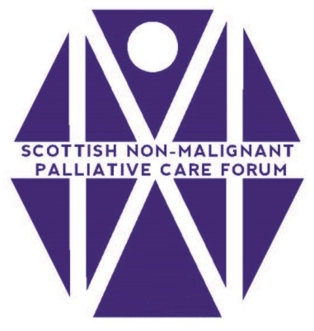
Geographical Area (please indicate one with a X)
Ayrshire & Arran □ Lothian □ Borders □ Grampian □ Fife □
Dumfries & Galloway □ Forth Valley □ Lanarkshire □ Highland □ Orkney □
Orkney □ Shetland □ Tayside □ Western isles □
Scotland wide □ Greater Glasgow & Clyde □ Third Sector □

Main Area of Work (please indicate onewith a X)
Clinical Practice □ Research □ Education □ Quality/Audit □
Management/Leadership □ other (specify) ………………………………………………………………..

Position (please indicate one)
Nurse: (specify role) ………………………………………………………………..
Doctor: (specify role) ………………………………………………………………..
AHP: (specify role) ………………………………………………………………..
Lecturer; (specify role) ………………………………………………………………..
Researcher: (specify role) ………………………………………………………………..
Other: (specify role) ………………………………………………………………..

Current base
Acute Hospital □ Community Hospital □ Community Team □
General Practice □ Hospice □ Palliative care team □
Rehabilitation □ Day Hospital □ Nursing Home □
University/College □ Other: (please specify) ……………………………………………………

I hereby request to become a member of the Scottish Non Malignant Palliative Care Forum.
Returning this form using either your work or personal e-mail account will indicate that you wish to remain/become a member of the SNMPCF

SIGNATURE: ………………………………………………………………….. DATE……………………………

Please email this form to: Betty Graham, committee member SNMPCF, betty.graham@nhs.net

